**VISVESVARAYA TECHNOLOGICAL UNIVERSITY**

**“JnanaSangama”, Belgaum -590014, Karnataka.**



# LAB REPORT

**on**

OBJECT ORIENTED MODELING AND DESIGN

***Submitted by***

# SHARAN S PAI (1BM19CS146)

***in partial fulfillment for the award of the degree of***

**BACHELOR OF ENGINEERING**

***in***

# COMPUTER SCIENCE AND ENGINEERING



**B.M.S. COLLEGE OF ENGINEERING**

**(Autonomous Institution under VTU)**

# BENGALURU-560019

**May-2022 to July-2022**

# B. M. S. College of Engineering,

**Bull Temple Road, Bangalore 560019**

(Affiliated To Visvesvaraya Technological University, Belgaum)

**Department of Computer Science and Engineering**



**CERTIFICATE**

This is to certify that the Lab work entitled “OBJECT ORIENTED MODELING AND DESIGN” carried out by SHARAN S PAI (1BM19CS146), who is Bonafede student of B. M.

S. College of Engineering. It is in partial fulfillment for the award of Bachelor of Engineering in Computer Science and Engineering of the Visvesvaraya Technological University, Belgaum during the year 2022. The Lab report has been approved as it satisfies the academic requirements in respect of object oriented modeling and designing - (20CS6PCOMD) work prescribed for the said degree.

LATHA N R

PROFESSOR

BMSCE

BANGALURU

**Index Sheet**

|  |  |  |
| --- | --- | --- |
| **Sl.**  **No.** | **Experiment Title** | **Page No.** |
| **1** | **COLLEGE MANAGEMENT SYSTEM** |  |
| **2** | **HOSTEL MANAGEMENT SYSTEM** |  |
| **3** | **STOCK MAINTENANCE SYSTEM** |  |
| **4** | **COFFEE VENDING MACHINE** |  |
| **5** | **ONLINE SHOPPING SYSTEM** |  |
| **6** | **RAILWAY RESERVATION SYSTEM** |  |
| **7** | **GRAPHICS EDITOR SYSTEM** |  |
|  |  |  |
|  |  |  |
|  |  |  |
|  |  |  |
|  |  |  |
|  |  |  |
|  |  |  |
|  |  |  |

**Course Outcome**





* **CLASS DIAGRAM**

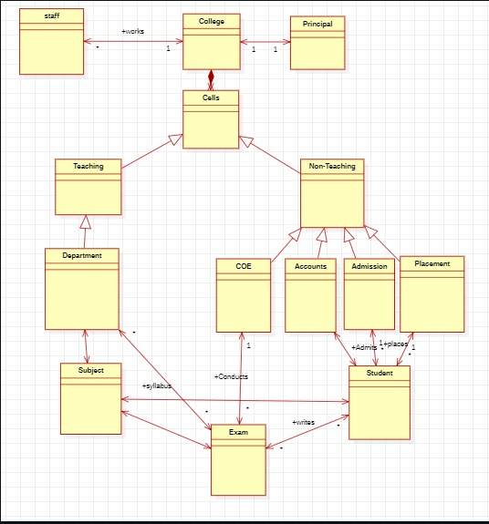

* **STATE DIAGRAM**

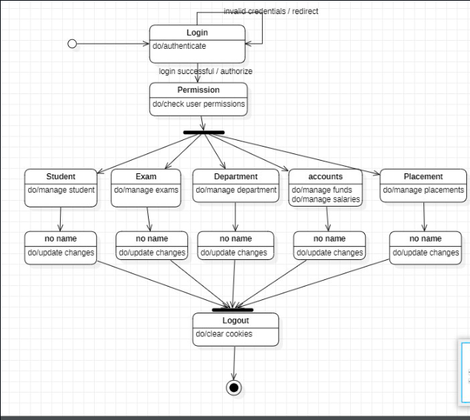

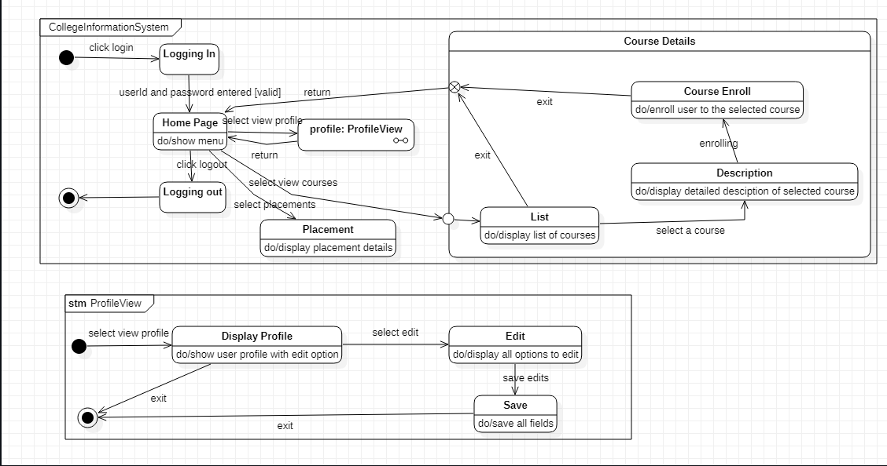



* 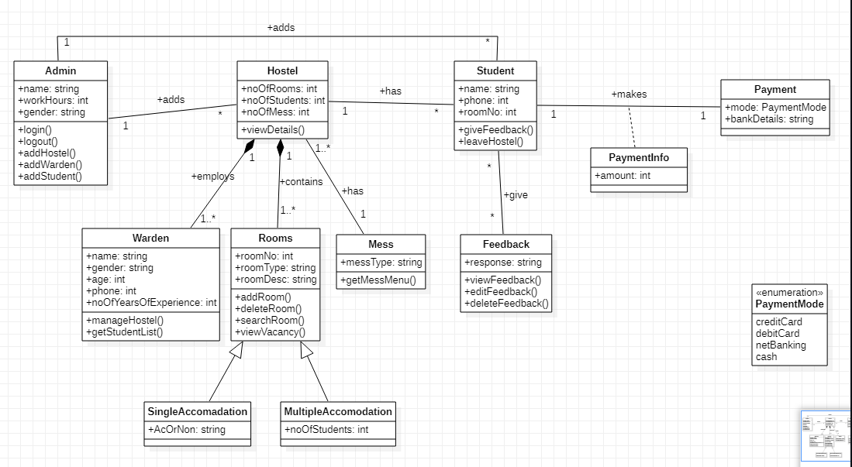**CLASS DIAGRAM**
* **STATE DIAGRAM**

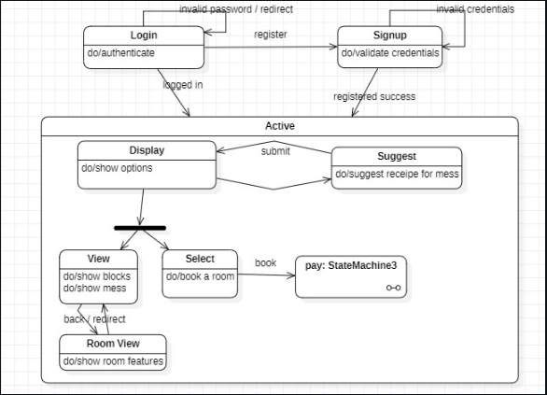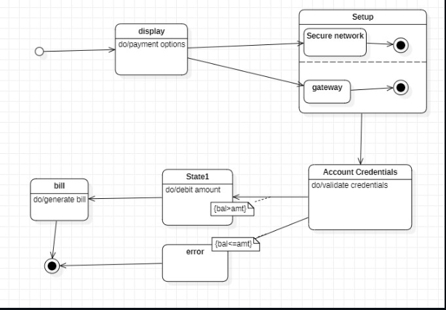



* 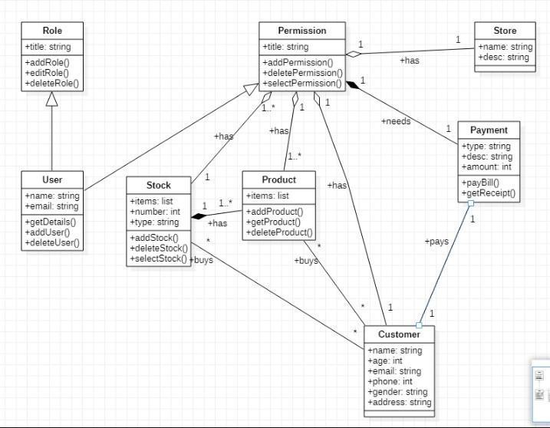**CLASS DIAGRAM**
* **STATE DIAGRAM**

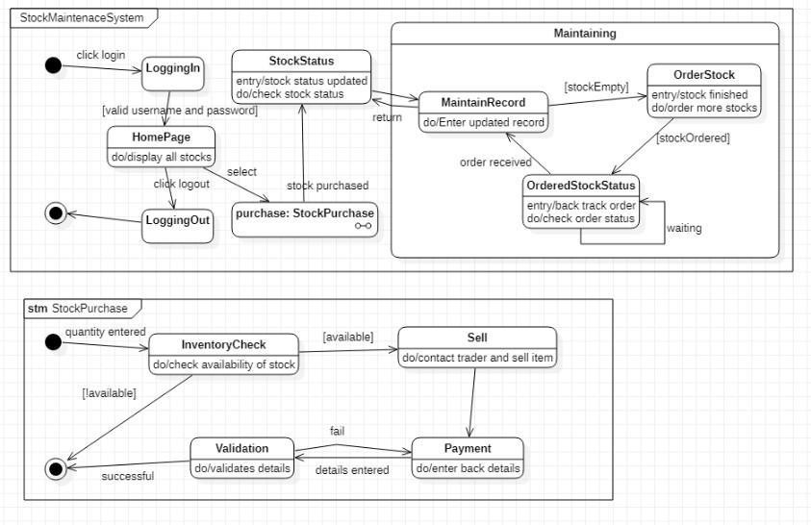



* **CLASS DIAGRAM**

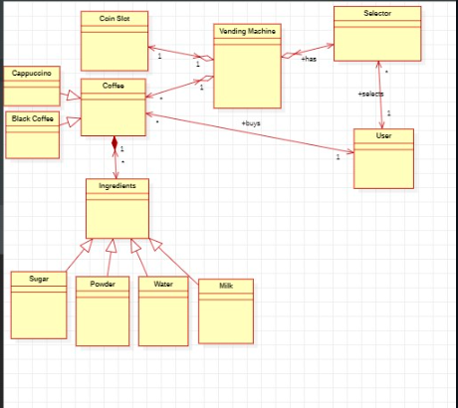

* **STATE DIAGRAM**

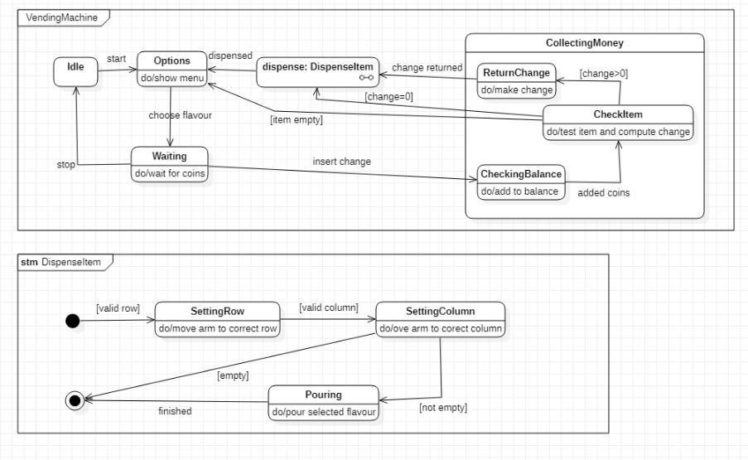

* **CLASS DIAGRAM** 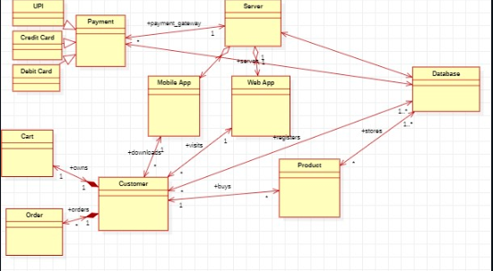
* **STATE DIAGRAM**

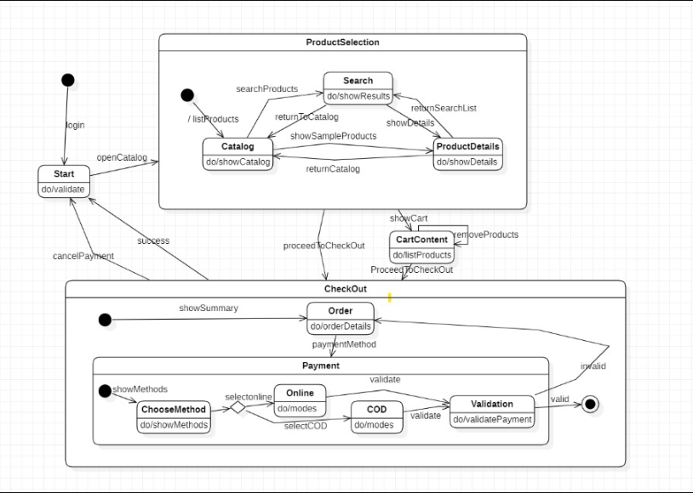



* 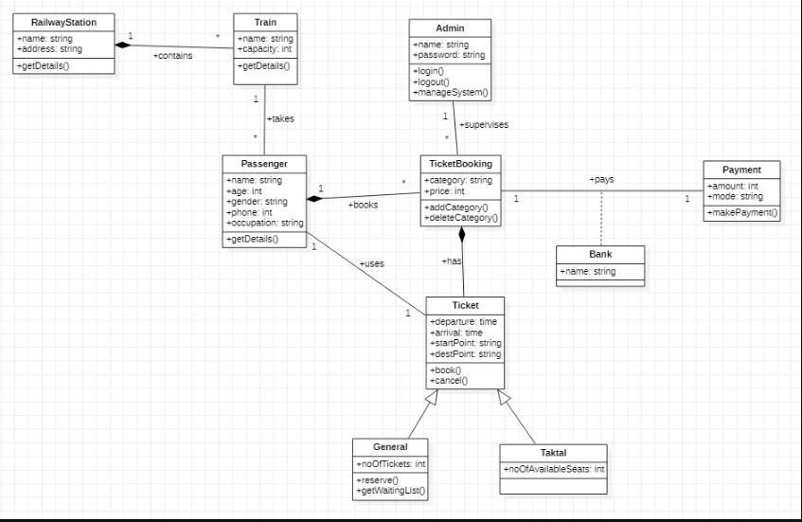**CLASS DIAGRAM**
* **STATE DIAGRAM**

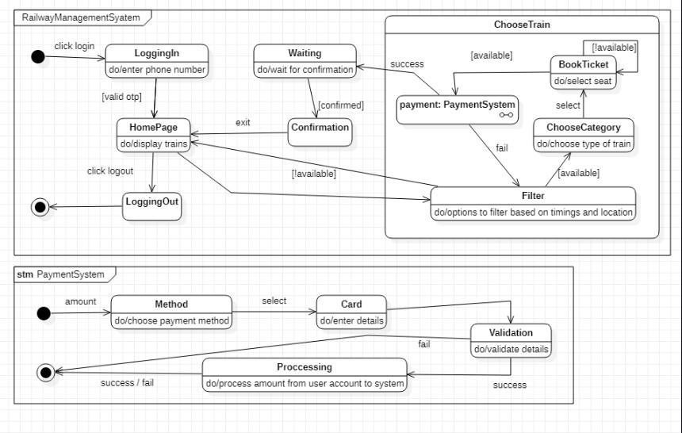



* 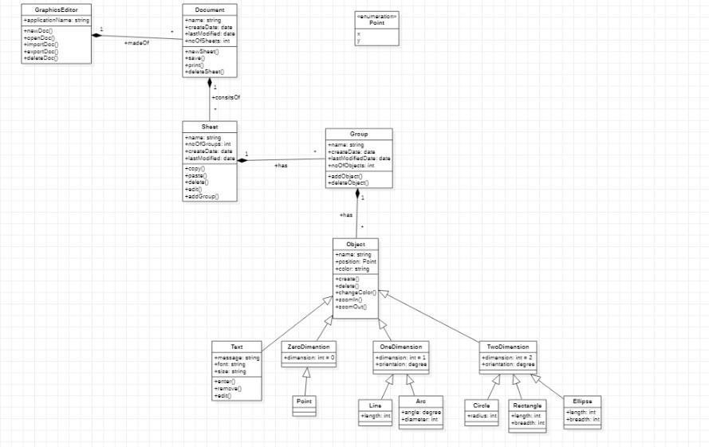**CLASS DIAGRAM**
* **STATE DIAGRAM**

